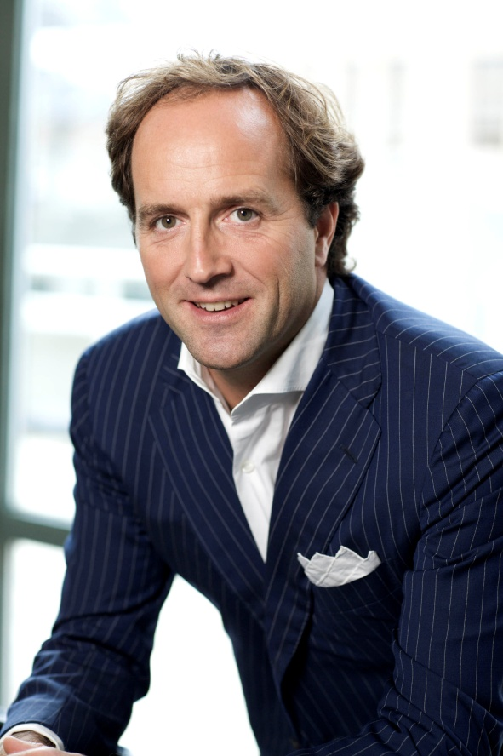
David Jones
Global CEO, Havas
Global CEO, Euro RSCG Worldwide
Co-Founder One Young World
Honored by the World Economic Forum as a Young Global Leader, David Jones has distinguished himself as an industry visionary and proponent of corporate responsibility and social change. He is the youngest global CEO in the history of advertising, heading both Havas and Euro RSCG Worldwide.
He was the driving force behind Kofi Annan’s TckTckTck Campaign for Climate Justice, one of the most successful cause campaigns in history, with 18 million people signing up as climate allies, and is co-founder of One Young World (described by CNN as the “junior Davos”), a nonprofit organisation that provides brilliant young people with a global platform through which to effect positive change.
David is the creator of the Social Business Idea™ and author of best-selling book Who Cares Wins: Why Good Business Is Better Business, published in December 2011 by Pearson/FT Publishing.
He also worked closely with David Cameron and the U.K. Conservative Party from 2007 up to and including Cameron’s election as prime minister in 2010.
David is a member of the Facebook Client Council. He was inducted into the American Advertising Federation’s Hall of Achievement in 2005, was voted one of the two top executives of the decade by readers of Adweek, was nominated as one of CR Magazine’s 2011 Responsible CEOs of the Year, and was named to the 40 Under 40 lists of both Crain's New York Business and Advertising Age.

Source: Cannes Lions

