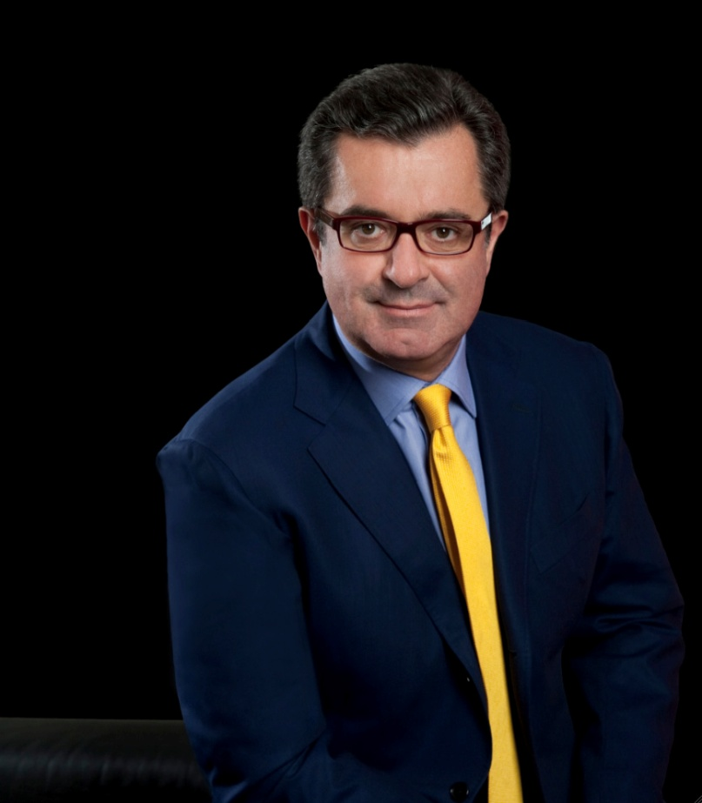
Mainardo de Nardis
CEO OMD Worldwide
Sharper Insights A dynamic vision for the future. As CEO of OMD Worldwide, Mainardo is delivering on an aggressive agenda for the global network: one agency unified by an ambitious vision delivering it via a common operating system that integrates all aspects of the media ecosystem.
The former CEO of both Aegis Media and Mediaedge:cia worldwide, Mainardo brings a wealth of proven experience and an entrepreneurial spirit.
Inspiring Ideas
For 30 years Mainardo has approached every client relationship with the same passion and commitment that defined his first experience at Y&R Milan. His inspiration ensures similar dedication among OMD’s 8500 talented professionals across cultures and disciplines. Under his tenure, OMD has twice been named Global Media Agency of the Year by Adweek and recognised as the world’s most creative media agency for an unprecedented fifth consecutive year by The Gunn Report for Media. RECMA also ranked OMD as number one globally in both 2010 and 2011 in their diagnostic report across twelve parameters.
Sustainable Results
A constant visionary, Mainardo founded and served as Chairman of MediaNetwork International, a European Association of local media independents dedicated to breaking new ground in the industry. In the 80's he was also a co-founder of one of Italy's 'third wave' ad agencies and later of the first media agency in that market. In 1993 he published "The European Media Map", one of the first books on the development of the European and global media scene.
An internationally recognised thought leader in media innovation, Mainardo will Chair the Cannes Festival Media Jury in 2012. He resides in New York and London with his family.
Source: Cannes Lions

